Birla Institute of Technology and Science, Pilani

**Android Quiz Application**

**Project Report**

***Submitted By***

***2015HW69202 Devesh Singh***

***2015HW69203 Dharmender Singh***

***2015HW69204 Dinkar Bhagat***

***2015HW69212 Garima Patel***

***2015HW69219 Gurvinder Kaur***

***2015HW69224 Hemant Sharma***

A Project Submitted in the partial fulfilment of the requirements for the degree of Master of Technology in Software Engineering.

**ABSTRACT**

Modern hand held devices such as smart phones have become increasingly powerful in recent years. However, there are some applications that allow users to flexibly execute tasks which are done by personal computer (PC), laptop etc. As mobile devices become more like PCs they will come to replace objects to accomplish necessary tasks. If any mobile applications has developed to mitigate administrative work as well as fulfil user (other than administrator) requirement, then task can be complete within the smart phone. **Bits Quiz application**, which is developed for Android base platform falls into this category.

The prime objective of **“Bits Quiz Application**” is to take quiz for any individuals through internet. Multiple choice questions (MCQ) will arrive for any interviewee with certain time limit for each quiz. All questions, answers and timer must be configure by an administrator and these administrative tasks including user creation can be done from “**Bits Quiz Application**”. Besides, report will generate with score where administrator can check for interviewee’s result.

**INTRODUCTION**

**Overview**

In today’s world, Smart phones have changed our lives and have become an indispensable part of our lives because of its specialty to simplify our routine work and thereby saving our time.

A Smartphone with an Android OS offers excellent functionality to the users offering a distinct experience. Android is a Linux based operating system and it was bought by Google in 2007.There are tons of application available and one of the prime reason for this vast number is android being an open source. On the other hand, android based device like mobile, tab are very user friendly.

**Objectives**

The main objective of “Bits Quiz App” is to facilitate a user friendly environment for all users and reduces the manual effort. In past days quiz is conducted manually but in further resolution of the technology we are able to generate the score and pose the queries automatically. The functional requirements include to create users that are going to participate in the quiz, automatic score and report generation and administrative tasks like add, delete, update for admin privilege users.

In this application, all the permissions lies with the administrator i.e., specifying the details of the quiz with checking result will show to interviewee or not, addition of question and answers, marks for each question, Set timer for each quiz and generate report with score for each quiz.

**Motivation**

Currently most of the Examination like organizational recruitment, University class test are paper based, which costs time and resources. Questionnaire is developed, printed, and then collect data, entry, editing, cleaning, which time consuming and costly.

Proposed application is the starting for avoid those circumstances which are been currently faced by any organization.

**Summary**

Dramatic breakthroughs in processing power along with the number of extra features included in mobile devices have opened the doors to a wide range of commercial possibilities. In particular, most cell phones regularly include processors comparable to PCs and internet access from a few years ago. With all these added abilities, Online Quiz application is design for Android based system mobile.

**Proposed Model**

**Purpose of the project**

This Project main purpose is to develop Online Quiz system named ‘BITS QUIZ’. The application (BITS QUIZ) will provide online based quiz with multiple choice question (MCQ). This quiz application will support android base operating system(Android Jelly Bean 4.1 to Oreo 8.0).

**Basic Structure Of Application**

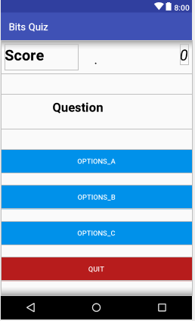

**Implementation**

**Technologies Used to development for this Application**

* Microsoft Window 8
* JAVA Development Kit(JDK 1.8)
* Android SDK
* Android Studio 3.0.1
* Deployment Target**:- Motorola MotoG3(Android 6.0.1 , API 23)**

**System Requirement**

|  |  |  |  |  |
| --- | --- | --- | --- | --- |
| Device | Operating System (OS) | OS Version | RAM | Disk Space |
| Android Mobile/Tab | Android | 4.0.x to higher | 100 MB or higher | 20 MB |

Getting Started

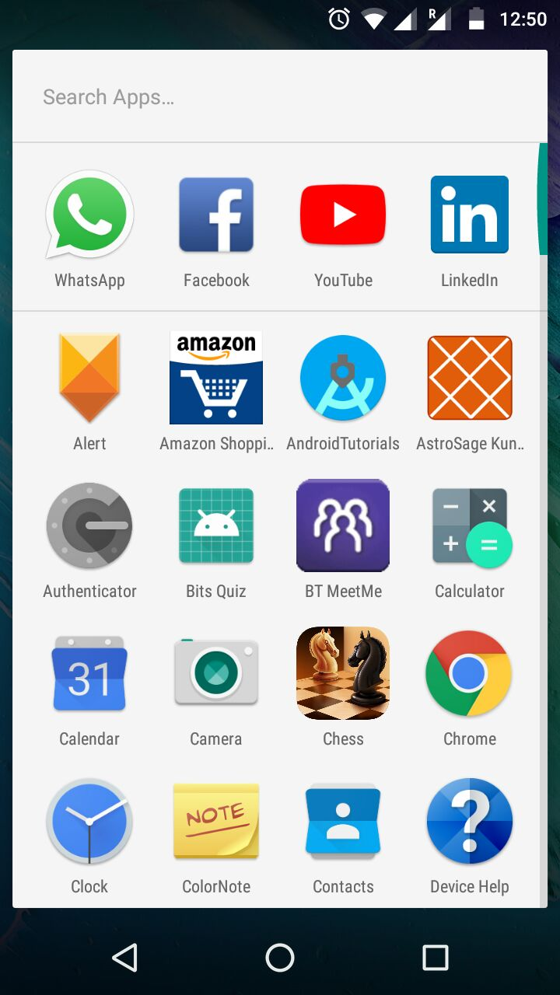

Tap the icon to open the application.(Bits Quiz)

**The quiz will start after opening the application. This screen will appear in front of user**.

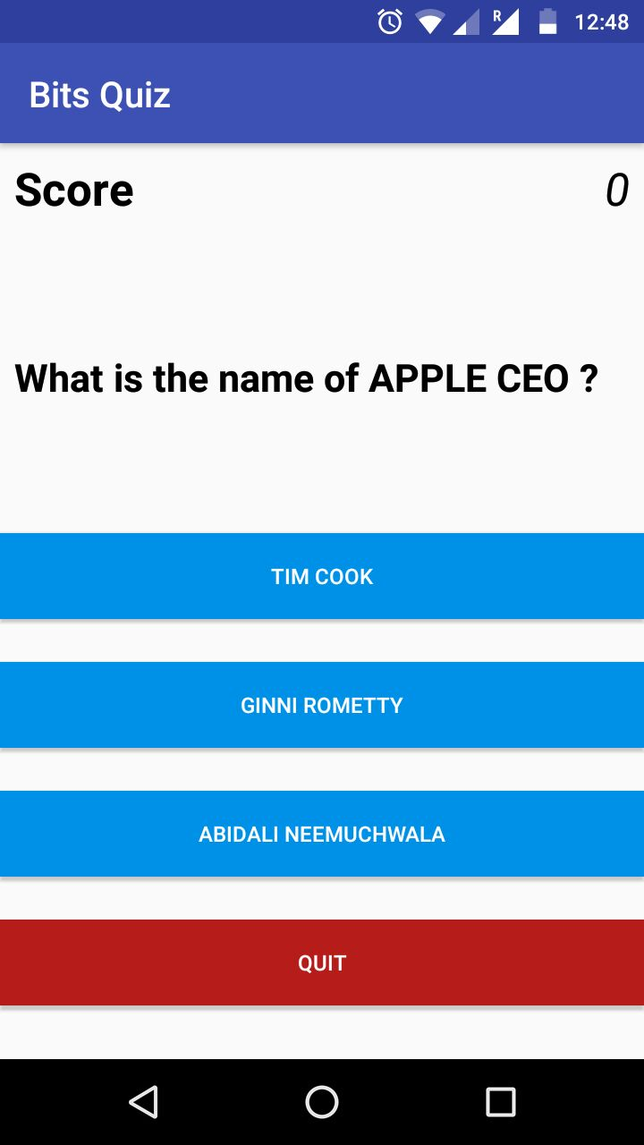

* In the top of application you can see the application name.
* In the score text field you can see your score. If you will select a right option you will get a message “correct Answer” and you score will be plus +1 and it will fetch you in next question.

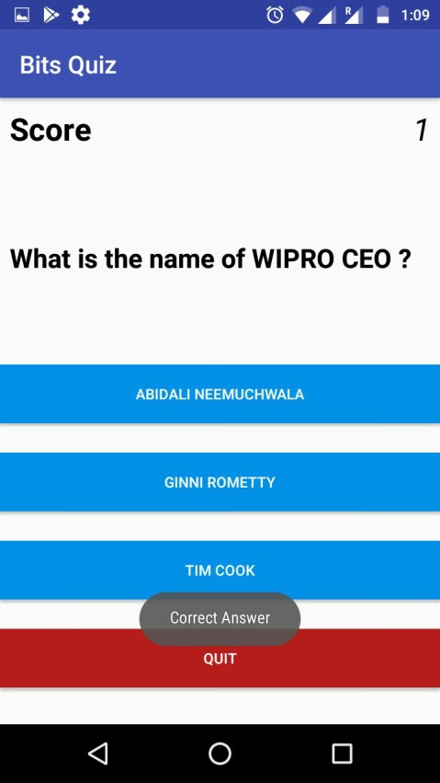

* If you will choose a wrong answer then you will get a message that “Wrong answer” and there will be no increment in your score and you get a next question.

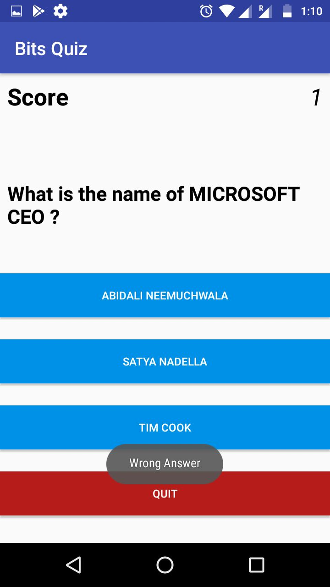

* There is an one quit button for exit the application. If you will click the quit button you will get exit from the application.

**Project Structure**

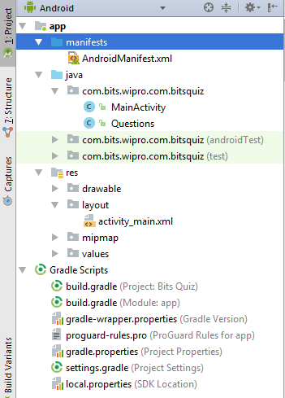

**Android Mainfest.XML**

Every application must have an AndroidManifest.xml  in its root directory. The manifest file provides essential information about your app to the Android system, which the system must have before it can run any of the app's code.

**Here the code:**

*<?***xml version="1.0" encoding="utf-8"***?>*<**manifest xmlns:android="http://schemas.android.com/apk/res/android"  
 package="com.bits.wipro.com.bitsquiz"**>  
  
 <**application  
 android:allowBackup="true"  
 android:icon="@mipmap/ic_launcher"  
 android:label="@string/app_name"  
 android:roundIcon="@mipmap/ic_launcher_round"  
 android:supportsRtl="true"  
 android:theme="@style/AppTheme"**>  
 <**activity android:name=".MainActivity"**>  
 <**intent-filter**>  
 <**action android:name="android.intent.action.MAIN"** />  
  
 <**category android:name="android.intent.category.LAUNCHER"** />  
 </**intent-filter**>  
 </**activity**>  
 </**application**>  
  
</**manifest**>

**JAVA Files:-**

In this application there are two java files.

1. MainActivity.java
2. Questions.java

**MainActivity.java code:-**

**package** com.bits.wipro.com.bitsquiz;  
  
**import** android.support.v7.app.AppCompatActivity;  
**import** android.os.Bundle;  
**import** android.view.View;  
**import** android.widget.Button;  
**import** android.widget.TextView;  
**import** android.widget.Toast;  
  
  
  
**public class** MainActivity **extends** AppCompatActivity {  
  
 **private** Questions **mQuestion** = **new** Questions();  
 **private** TextView **mScoreView**;  
 **private** TextView **mQuestionView**;  
 **private** Button **mButtonChoice1**;  
 **private** Button **mButtonChoice2**;  
 **private** Button **mButtonChoice3**;  
 **private** Button **quit**;  
  
 **private** String **mAnswer**;  
 **protected int mScore** = 0;  
 **private int mQuestionNumber** = 0;  
  
  
  
 @Override  
 **protected void** onCreate(Bundle savedInstanceState) {  
 **super**.onCreate(savedInstanceState);  
 setContentView(R.layout.***activity_main***);  
  
  
 **mScoreView** = (TextView) findViewById(R.id.***score***);  
 **mQuestionView** = (TextView) findViewById(R.id.***question***);  
 **mButtonChoice1** = (Button) findViewById(R.id.***choice1***);  
 **mButtonChoice2** = (Button) findViewById(R.id.***choice2***);  
 **mButtonChoice3** = (Button) findViewById(R.id.***choice3***);  
 **quit** = (Button)findViewById(R.id.***quit***);  
  
 updateQuestion();  
  
 **quit**.setOnClickListener(**new** View.OnClickListener() {  
 @Override  
 **public void** onClick(View view) {  
 finish();  
 System.*exit*(0);  
 }  
 });  
  
  
 **mButtonChoice1**.setOnClickListener(**new** View.OnClickListener() {  
 @Override  
 **public void** onClick(View view) {  
  
 **if** (**mButtonChoice1**.getText() == **mAnswer**) {  
 **mScore** = **mScore** + 1;  
 updateScore(**mScore**);  
 updateQuestion();  
  
 Toast.*makeText*(MainActivity.**this**, **"Correct Answer"**, Toast.***LENGTH_SHORT***).show();  
 } **else** {  
 Toast.*makeText*(MainActivity.**this**, **"Wrong Answer"**, Toast.***LENGTH_SHORT***).show();  
 updateQuestion();  
 }  
 }  
 });  
  
 **mButtonChoice2**.setOnClickListener(**new** View.OnClickListener() {  
 @Override  
 **public void** onClick(View view) {  
  
 **if** (**mButtonChoice2**.getText() == **mAnswer**) {  
 **mScore** = **mScore** + 1;  
 updateScore(**mScore**);  
 updateQuestion();  
  
 Toast.*makeText*(MainActivity.**this**, **"Correct Answer"**, Toast.***LENGTH_SHORT***).show();  
 } **else** {  
 Toast.*makeText*(MainActivity.**this**, **"Wrong Answer"**, Toast.***LENGTH_SHORT***).show();  
 updateQuestion();  
 }  
 }  
 });  
  
  
 **mButtonChoice3**.setOnClickListener(**new** View.OnClickListener() {  
 @Override  
 **public void** onClick(View view) {  
  
 **if** (**mButtonChoice3**.getText() == **mAnswer**) {  
 **mScore** = **mScore** + 1;  
 updateScore(**mScore**);  
 updateQuestion();  
  
 Toast.*makeText*(MainActivity.**this**, **"Correct Answer"**, Toast.***LENGTH_SHORT***).show();  
 } **else** {  
 Toast.*makeText*(MainActivity.**this**, **"Wrong Answer"**, Toast.***LENGTH_SHORT***).show();  
 updateQuestion();  
 }  
 }  
 });}  
  
  
  
 **private void** updateQuestion() {  
 **mQuestionView**.setText(**mQuestion**.getQuestion(**mQuestionNumber**));  
 **mButtonChoice1**.setText(**mQuestion**.getChoice1(**mQuestionNumber**));  
 **mButtonChoice2**.setText(**mQuestion**.getChoice2(**mQuestionNumber**));  
 **mButtonChoice3**.setText(**mQuestion**.getChoice3(**mQuestionNumber**));  
  
 **mAnswer** = **mQuestion**.getCorrectAnswer(**mQuestionNumber**);  
 **mQuestionNumber**++;  
  
 }  
  
  
 **private** Void updateScore(**int** point){  
 **mScoreView**.setText(**""** +**mScore**);  
 **return null**;  
  
  
 }  
  
  
  
  
 }

**Question.java code:-**

**package** com.bits.wipro.com.bitsquiz;  
  
**public class** Questions {  
  
 **private** String **mQuestion** [] ={  
  
 **"What is the name of APPLE CEO ?"**,  
 **"What is the name of WIPRO CEO ?"**,  
 **"What is the name of GOOGLE CEO ?"**,  
 **"What is the name of MICROSOFT CEO ?"**,  
 **"What is the name of IBM CEO ?"**,  
 **"What is the name of TCS CEO ?"**};  
  
 **private** String **mChoices**[][] = {  
  
 {**"Tim Cook"**,**"Ginni Rometty"**,**"Abidali Neemuchwala"**},  
 {**"Abidali Neemuchwala"**,**"Ginni Rometty"**,**"Tim Cook"**},  
 {**"Ginni Rometty"**,**"Sundar Pichai"**,**"Tim Cook"**},  
 {**"Abidali Neemuchwala"**,**"Satya Nadella"**,**"Tim Cook"**},  
 {**"Satya Nadella"**,**"Ginni Rometty"**,**"Ginni Rometty"**},  
 {**"Rajesh Gopinathan "**,**"Sundar Pichai"**,**"Tim Cook"**},  
  
 };  
  
  
 **private** String **mCorrectAnswers**[] = {**"Tim Cook"**,**"Abidali Neemuchwala"**,**"Sundar Pichai"**,**"Satya Nadella"**,**"Ginni Rometty"**,**"Rajesh Gopinathan"**};  
  
 **public** String getQuestion(**int** a) {  
 String question =**mQuestion**[a];  
 **return** question;  
 }  
 **public** String getChoice1(**int** a){  
 String choice0 = **mChoices**[a][0];  
 **return** choice0;  
 }  
  
 **public** String getChoice2(**int** a){  
 String choice1 = **mChoices**[a][1];  
 **return** choice1;  
 }  
 **public** String getChoice3(**int** a){  
 String choice2 = **mChoices**[a][2];  
 **return** choice2;  
 }  
  
 **public** String getCorrectAnswer(**int** a){  
  
 String answer = **mCorrectAnswers**[a];  
 **return** answer;  
 }  
  
  
  
  
  
  
}

**build.gradle file code:-**

apply **plugin**: **'com.android.application'**android {  
 compileSdkVersion 26  
 defaultConfig {  
 applicationId **"com.bits.wipro.com.bitsquiz"** minSdkVersion 16  
 targetSdkVersion 26  
 versionCode 1  
 versionName **"1.0"** testInstrumentationRunner **"android.support.test.runner.AndroidJUnitRunner"** }  
 buildTypes {  
 release {  
 minifyEnabled **false** proguardFiles getDefaultProguardFile(**'proguard-android.txt'**), **'proguard-rules.pro'** }  
 }  
}  
  
dependencies {  
 implementation fileTree(**dir**: **'libs'**, **include**: [**'*.jar'**])  
 implementation **'com.android.support:appcompat-v7:26.1.0'** implementation **'com.android.support.constraint:constraint-layout:1.0.2'** testImplementation **'junit:junit:4.12'** androidTestImplementation **'com.android.support.test:runner:1.0.1'** androidTestImplementation **'com.android.support.test.espresso:espresso-core:3.0.1'**}

**Reference:-**

**https://developer.android.com**